**THE BEE LINE IS THE MONTHLY NEWSLETTER OF THE MIDWESTERN BEEKEEPERS ASSOCIATION**

**VOLUME 68** • **NUMBER 3**

Membership dues are $15 per year

(Jan 1 – Dec 31)

Dues for new Members after July 1 are $7.50

Membership entitles you to:

* Monthly newsletter
* 30-day loan of books from our library
* Free advertising in the newsletter
* Monthly meetings
* Midwestern Beekeepers Association Members closed group on Facebook

We also encourage our members to join the Missouri State Beekeepers Association

[www.midwesternbeekeepers.org](http://www.midwesternbeekeepers.org/)

[](http://www.facebook.com/group.php?gid=103317166387261)

**Midwestern Beekeeper’s Association**



**MidwstnBeekprsA**

**Deadline for newsletter submission is the 25th of each month.**

***In case of inclement weather on the day of a meeting, please check one of the above or call an officer.***

**2015 Membership is now due.**

**Memberships not renewed will be removed from our newsletter list beginning with our April issue.**

**If you did not receive an email from Midwestern Beekeepers Association in February, please contact Tanya Fisher to verify the email address we have for you.**

THE BEE LINE

March 2015

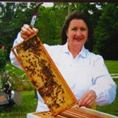

Wisps of Smoke

***By Cathy Misko***

The howling wind is literally whipping around my house as I type but early spring is *still* my guess. Until the night before March 20th I have a 50% chance to be right! Crocuses were blooming a few weeks ago and the girls were bringing in some willow pollen. Everything has certainly been halted with the snow and teens this week. However, it is a great time to scrap brittle propolis off supers and frames before the warm temperature transforms the glue to a sticky gummy mess. Ready to work, I have bought my 50 pounds of White Dutch clover and will be working off my winter arm flab to plant it!

March can be brutal so keep a watch on food stores and assure food stays in contact with the cluster. I have started feeding 1:1 syrup from the inside of light hives on days that bees are flying in hope that they can place liquid feed close to the brood nest if needed. For those who applied candy boards or sugar mush, reports are that the girls are feasting on it! As the bees break cluster they can rearrange the liquid food stores as long as they have food to rearrange. With the extreme shifts in the weather I hope all is well and I get to make spits with healthy colonies.

It is a joy on the warm days to see the girls taking cleansing flights but we have not had temperatures high enough to do intensive inspections. As soon as the temps are in the 60’s, sunny, and low winds I hope to

reverse brood chambers *if* all the bees are in the top. Hopefully I’ll see 5-7 frames covered with bees. Accurate care should be given to *not* separate the brood nest during manipulations. Avoid relocating part of the cluster in the upper edge of the top box and the rest of cluster in the lower edge of the bottom box leaving empty broodless space in-between. To examine the brood nest, I’ll wait until the 70’s to avoid chilling the brood, work quickly, and place frames in a covered and protected nuc box as I inspect. Excited for spring, I need to take care to not start making my nucs until temperatures stay consistent between 50 -70 degrees for the same reason to not chill the brood or split too few of bees to keep themselves warm. The Midwest is known for having cold snaps; I will not forget the shock of receiving 8 inches of snow on May 3rd a couple of years ago. Many packages were lost due to not having liquid feed above the newly installed bees after low temperatures forced them to cluster.

By the time you read this we would have conducted our *20th Beginning Beekeeping Workshop* which is always a highlight. Many newly excited beekeepers full of brilliant ideas, dreams of how they hope to help the bees, and visions of how the bees will likewise help them will also have been added to the ranks. Some attendees will have beekeeping experience desiring to glean more education to protect their investment and their bees!

Speaking of workshops, our northern Midwestern beekeepers are presenting a *Beginning Beekeeping Course* in Maryville March 21st with the assistance of the Northwest Bee Busters and the sponsorship of the University of Missouri Extension. Kudos!

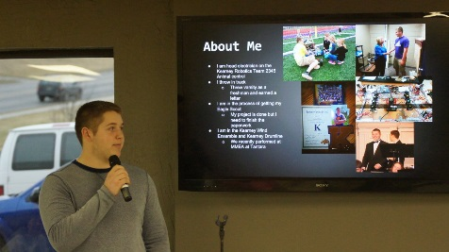The *beekeeping revolution* I dubbed last year continues… There are beekeeping classes all over the Midwest and all over the country! With so much interest, the future looks grand for the beekeeping industry. Midwestern’s goal is to promote education and in turn provide a sound foundation for successful beekeeping.

Garrett Miller-2014 Scholarship Student

With this goal I am pleased to announce that we had awarded various scholarships to 5 more deserving youth. Keep your eyes open; it may be one of these students that we have to pay big bucks to in order hear speak at a national conference someday…oh the possibilities.

Big thanks last month to Tom Britz for a powerful and educational late winter management presentation that he borrowed from Dewey Caron and his *Honey Bee Biology and Beekeeping* text. Dewey is a beekeeping giant in my eyes and one of the best teachers that I have gleaned from. It was obvious how Tom also has been inspired. You may now find Dewey’s book in our library.

Thank you Scholarship Student Garrett Miller for inspiring us with an excellent presentation.

We better perk up…Garrett is the second student publicizing a harvested bumper crop of honey in the first year. Yes weather and location has a bit to do with nectar flow but my hat is also off to the mentors…

Good job Steve Boxx and the rest of the mentors investing in these students!

March 9th many of us will learn how to assemble the EZ Nucs…maybe a Midwestern YouTube video will make us famous or at least give a few laughs.

I look forward to Doug Pontious covering *Woodenware* and Laura presenting *Location: Urban and Rural*. Our March 15th Meeting will have double excitement for we will be seeing many new faces; be sure to shake a hand and wear your name tags!

**Missouri State Beekeeper Steve Harris**

**July 2, 1947-February 20, 2015**

We extend our heartfelt condolences to Steve’s family. Steve had a deep love for beekeeping and for bringing laughter to those around him.

Those wishing to honor his memory may contribute to:

Wounded Warrior Project, PO Box 75817, Topeka, KS 66675

**Welcome New Members**

Aron Boudreaux & JennaVee Johnson Lee’s Summit, MO

Ann Brock Garden City, MO

Rick Couch        (welcome back) Independence, MO

Tyler Davis  Kansas City, MO

Rebecca Hartman & Steve Basinger Pleasant Hill, MO

Nicole & Michael LaPlante Grain Valley, MO

Dean Matthews Holden, MO

Cassidy McCrite Topeka, KS

Erik & Rachael Messner Kansas City, MO

Adam Murphy Raymore, MO

Debbie Paquin Holt, MO

Donald Phillips Kansas City, MO

Richard Roberts Raytown, MO

Shelby Seymour Sibley, MO

Peggy Walsh Prairie Village, KS

Frank Austenfeld Belton, MO

Neil Wilkerson Kansas City, MO

Charles Wolven Plattsburg, MO

**Join us early at 1:30 to help set up the room and for net-working! Come on spring!**

**Congratulations!**

We are proud to announce the new 2015 Youth AwardRecipients

***2015 Apis Award***

Alana Bauer

Svetlana Ehlers

Bailey Roos

***2015 MBA Scholarship Award***

Shelby Copeland

Seth McGraw



**Bass Pro**

**“Special Gathering”**

**“Nucs and More”**

**April 2nd**

**@ 7:00 p.m.**



**March General Meeting**

**Sunday, March 15, 2015 *2:30 PM***

**Graceway Church Fellowship Hall**

**5460 Blue Ridge Cutoff**

**Kansas City MO**

*March 15th program will be "Woodenware Assembly" This will be led by Doug Pontious.  He will be demonstrating assembly of woodenware. Do I glue or staple or screw? Where do I glue? What glue do I use? I don’t know!! Well, Doug knows and he is walking us through how to assemble the parts to our hives.  He also wires his frames so he will be sharing some secrets on that skill!*

*Following Doug, we will have "Apiary Location (Urban and Rural). I, Laura Fish, will be covering the topic of choosing your hive locations!*

*Please, remember to bring a donation for REAP! Our bucket overflows quite often and that is so wonderful to see!  Some folks recently asked if we could supply money donation envelopes to cover for the month that they forget to bring something to donate.  I would suggest that you just bring double the items the next month.  (Cash hanging around might not be the best idea!) No worries- the bucket will be there when you remember!!*

*See you in March! Sunday, March 15th at 2:30 pm.  Graceway Church in the Fellowship Hall (downstairs).*

###### Midwestern Beekeepers

###### 2015 General Meetings Graceway Church

###### Fellowship Hall

**Mar. 15, (Sunday) 2:30 pm**

**Apr. 16, (Thursday) 7:00 pm**

**May 21, (Thursday) 7:00 pm**

**Jun. 18, (Thursday) 7:00 pm**

**Jul. 16, (Thursday) 7:00 pm**

**Aug. 9, (Sunday) 2:30 pm**

**Sep. 17, (Thursday) 7:00 pm**

**Oct. 15, (Thursday) 7:00 pm**

**Nov. 15, (Sunday) 2:30 pm**

**Dec. 13, (Sunday) 2:30 pm**

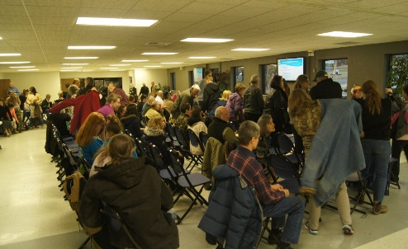

[](http://www.facebook.com/group.php?gid=103317166387261)

**Midwestern Beekeeper’s Association**

**Midwestern Beekeepers Association Members**

**Closed Group**

**2015 Officers**

**President**

Cathy Misko

321 SW 58 Highway

Centerview MO 64019

[cathymisko@earthlink.net](mailto:cathymisko@earthlink.net)

660-656-3485

**1st VP/Programs**

Laura Fish

6603 NW Gilley Road

Parkville MO 64152

[ddetailsfish@gmail.com](mailto:ddetailsfish@gmail.com)

816-809-1629

**2nd VP/Membership**

Tanya Fisher

P O Box 132

Raymore MO 64083

[t.fisher@kinglouie.com](mailto:t.fisher@kinglouie.com)

816-322-9245

**3rd VP/Publicity/Editor**

Janice Britz

12909 East 264th St.

Peculiar MO 64078

[britzjs@gmail.com](mailto:britzjs@gmail.com)

816-419-1327

**Secretary**

Cindy Connell

365 SW 1081

Holden MO 64040

[Goldwingers2004@yahoo.com](mailto:Goldwingers2004@yahoo.com)

816-732-6579

**Treasurer**

Wes Johnston

401 NW Heady Ave.

Ferrelview MO 64093

[Wj2@kc.rr.com](mailto:Wj2@kc.rr.com)

816-392-4960

**Auditor** Open

**1st Board Member**

Dean Sanders

37804 Old Pink Hill Rd.

Oak Grove MO 64075

816-456-4683

**2nd Board Member**

Steve De Caigney

204 S. Shrank Ave.

Independence MO 64056

816-257-5258

**MIDWESTERN BEEKEEPERS ASSOCIATION**

**Beekeeper of the Year Award Hall of Fame**

1962 A E McCoven

1963 Joe Maher

1964 J C Dodge

1965 A W Majors

1966 John Thornberry

1967 unassigned

1968 V O Dodge

1969 Bob Cornforth

1970 E W Johnson

1971 William Means

1972 Ivan Boyd

1973 Earl Honeycutt

1974 Joe Maher

1975 Paul Clegg

1976 Leo Erickson

1977 Chester Crain

1978 Roger Nichols

1979 Fleta Rose

1980 A W Majors

1981 Walt Bigelow

1982 Harry Knowles

1983 Willard Madole

1984 unassigned

1985 Paul Clegg (**after his death)**

1986 Clarence Vogeler

1987 D Carol Kjelshus

1988 Glenn Davis

1989 Joli Winer

1990 John Steffens

1991 Dick Scott

1992 Cecil Sweeney

1993 Bob Dye

1994 Mike Allen

1995 Ron Vivian

1996 Bob Harrison

1997 Ed Fisher

1998 Bill and Rose Terrill

1999 Joanne Davis

2000 Bob Justice

2001 Jerry and Donna Dowell

2002 Kathie Scott

2003 Felicia Villotti

2004 Diane Mallison

2005 Earl and Evelyn Sanford

2006 Bill Baxter

2007 Dean Sanders

2008 Robert Burns

2009 Andy Nowachek

2010 Jim and Tanya Fisher

2011 Cathy Misko

2012 Phil Levi

2013 Tom O'Neill

2014 Cindy and Jim Connell



Student Grace Sanders Receiving her Certificate of Ownership

Please enjoy *Honey Bee Biology and Beekeeping* by Dewey M. Caron

This has been donated to the Midwestern Beekeeper’s Library

**In the honorable memory of Robert Dye**

**Raytown Farmers' Market** is looking for a beekeeper using natural management to supply honey. For details

contact Elisa Bedsworth [www.raytownfarmersmarket.com](http://www.raytownfarmersmarket.com)

**Conferences & Events**

**March 7 & 15, 2015**

***Beginning Beekeeping Workshop***

**Midwestern Beekeeper’s Association**

**The 20th Annual Beginning Beekeeping Workshop is an all-day event at**

**The Point @ Graceway**

**5600 Blue Ridge Cutoff**

**March 13-14, 2015**

**The Kansas Honey Producers**

**2015 Spring Meeting**

[**www.kansashoneyproducers.org**](http://www.kansashoneyproducers.org)

**March 15 & 22, 2015**

**Northeastern Kansas Beekeepers Association**

**NEKBA Bee Classes**

[**www.nekba.org**](http://www.nekba.org)

**March 21, 2015**

***Beginning Beekeeping Course* Maryville, Mo   led by Midwestern Beekeepers in conjunction with Bee Busters and the University of Missouri Extension.** [*www.moveggrowers.org/beekeepingworkshops*](http://www.moveggrowers.org/beekeepingworkshops)

**Now- April 12, 2015**

***Extreme Bugs* @ Union Station** <www.unionstation.org/bugs>

**2015 Officers**

**3rd Board Member**

Terry O’Bryan

P O Box 92

Liberty MO 64069

[obryanterry@yahoo.com](mailto:obryanterry@yahoo.com)

816-805-6779

**Librarian**

Tom O’Neill

530 SE 425 Rd.

Warrensburg, MO 64093

[Thomaso3257@towerns.net](mailto:Thomaso3257@towerns.net)

660-747-7073

**MO Beekeepers Assn. Liaison**

Dean Sanders

37804 Old Pink Hill Rd.

Oak Grove MO 64075

816-456-4683

**Webmaster**

Cheryl Westra

8308 E 105th Terrace

Kansas City MO 64134

[cheryljwestra@gmail.com](mailto:cheryljwestra@gmail.com)

816-509-5883

**Honey Plants**

Tom Britz

12909 E 264th St.

Peculiar MO 64078

[Tbritz33@gmail.com](mailto:Tbritz33@gmail.com)

816-419-6816

**Hospitality**

Rick Messenger

20943 Highway O

Sedalia MO 65301

[Lindarick95@gmail.com](mailto:Lindarick95@gmail.com)

660-827-4489

**Nuc Initiative**

Stuart Dietz

14500 E 37 St. S.

Independence MO 64055

<stuartadietz@aol.com>

785-304-5905

**Urban Liaison**

Ezekiel A. Amador III

2708 Madison Ave.

Kansas City MO

[zekeamador@aol.com](mailto:zekeamador@aol.com)

816-612-9030

**C:\Users\Administrator.Britz-PC\AppData\Local\Microsoft\Windows\Temporary Internet Files\Content.IE5\DVECXLJB\MC900156753[1].wmf**

**April 25, 2015** **Midwestern Beekeeper’s Assn. will host a Beekeeping Educational Booth for approximately 20,000 passersby *@ Kansas City River Market.***

[www.kcrivermarket.com](http://www.kcrivermarket.com)

**February 18 thru April 28**

***Beginning to Intermediate***

***Honey bee class***

**Swarm Chasers Bee Group**

**816-261-8647 or**

**Conservation Department at 816-271-3100**

**May 2, 2015**

**8 am to 4pm**

**Queen Rearing Class**

**Midwestern Beekeepers Association**

**Jerry L. Litton Visitor Center**

**16311 State Route DD, Smithville, MO 64089**

**June 6, 2015**

**NEKBA Funday**

**Keynote Speakers:**

**Dr. Marla Spivak &**

**Dr. Chip Taylor**

[**www.nekba.org**](http://www.nekba.org)

*Basic Beekeeping by Roger Wood*

 In my mind, March 1 marks the beginning of the spring build up in Missouri. Granted, your bees have been raising brood most if not all of February, but the numbers were most probably small and very conservative (if you let things happen naturally). The bees instinctually will not risk losing brood by raising more bees than the colony can care for in any temperature. And temperatures can fluctuate wildly in late February and early March. This year, it has been unusually and constantly cold.

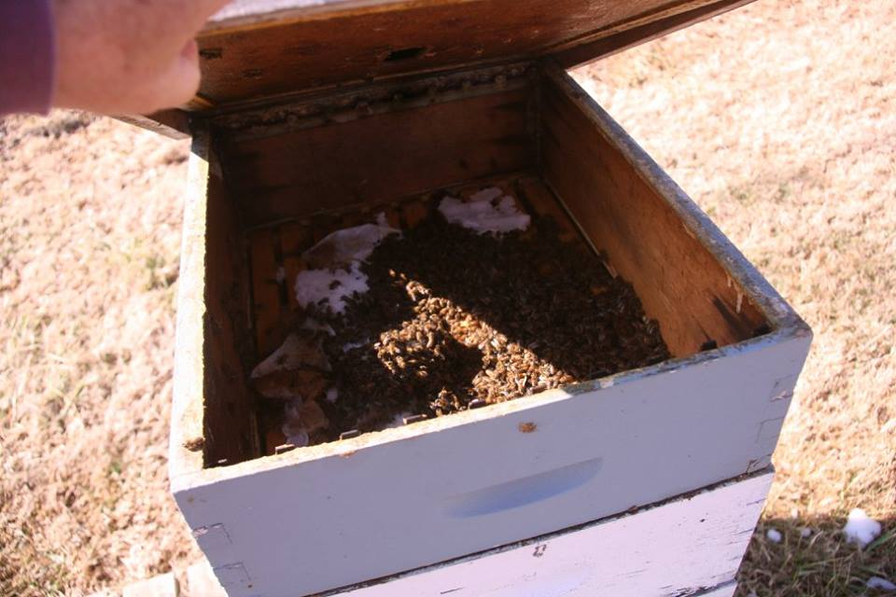The list of things to do grow in March so if you have that bee book handy we suggested you buy last December, read the parts on spring build up again. Weather permitting, you will make a full inspection of the hive and check for eggs, egg pattern, and number of brood frames (frames with the majority of cells with eggs, larva, or capped brood). It’s not so important that you actually see the queen (chances are good you will see her because the hive numbers will be relatively small), but you do want to see evidence of the queen doing what she should. If there is evidence of failure or no eggs, you must decide to either combine with another hive or find another laying queen. I’ll tell you, waiting to make this decision on a failing queen rarely works out well. Your hive falls further behind every day you keep a failing queen around. This is the hardest decision to make and learn but for your goals as well as the colony’s goals, you should not wait in making this decision. Try not to worry too much about the time it takes to correct this even though I have said this is so important. Naturally, the colony will eventually decide to replace the queen but you are just assisting this process by shortening the period that the colony only exists. It’s important only for your goals to build the colony to a strength necessary to collect surplus nectar. The colony is in trouble but it is manageable for a sharp beekeeper and even the unmanaged feral colony. Keep the old queen in the hive until you have the replacement. If the queen is missing (no eggs or multiple eggs in the same cell--laying worker), you will just try to correct the problem as quick as possible either combining with another hive or getting a new queen.

During this first tear down, keep a record of what you see. Figure out the number of frames to replace (bad or old comb) and come back on your next inspection with replacements. You can alternate empty comb and any capped honey above the nest and if there is pollen in frames, move them next to the nest if they are not. New pollen may already be seen there, and if it is, I wouldn’t worry about moving other pollen stored in the hive. Tear down to the floorboard and clean or replace with another clean floorboard. I swap out floorboards (I have screened bottom boards now) so I can look at the debris after I close the hive. I then clean the first hive’s floorboard to use with the next hive. If the bees are waiting in line to go into and out of the hive, rotate the entrance cleat to the next bigger size. More than not, brood nest size will still be fairly small, one to two full deep frames equivalent. (I won’t go into brood math here but you should investigate this subject further to expand your knowledge). If it is bigger, excellent. If it is smaller, you may have one of the varieties of bees that are a little slower to start brood raising. Do not confuse a good small nest with a failing queen nest. If the pattern is good regardless of size you are ok. Our target for the first of April is to have 3+ full frames of brood (both sides). If you measure your hive strength by the brood nest size, you eliminate the possible variability of the missing field bees when you make your inspection. Write all of your observations down such as: weather, flight traffic, brood nest size and brood pattern, number of bee covered frames, number of dead outside, number of dead being hauled out, location of the nest in the hive boxes, amount of honey frames. Then make note of what you did. Alternated empty comb and honey frames above nest, number of frames to be replaced, scraped bottom board, swapped bottom board, found shb larva in debris, etc. Anything that you notice. You cannot note too much.

The clock becomes the controlling factor in the spring build-up as we begin the approach to various nectar flows. If you do not plan to feed syrup, your buildup will depend on reserve stores and the ability of the cluster to access these stores without hindrance from the weather. Feeding allows the keeper to maximize their spring increase efficiency and to have the maximum flying force of mature bees ready for the first desirable nectar about the time of the fruit trees in April. Just to visit brood math again, field bees the first of April were eggs about 5-6 weeks prior (or more). So, the bee eggs I have in my hives today (Feb 21) and this next week are the bees that will be flying for me around April 1st. It’s important for you to realize that you are looking at your future 5 or 6 weeks from now during this first inspection.

So regardless of your decision to use syrup, you should rearrange the honey stores above the nest alternating honey frames with empty comb between to help the hive continue without any holdups due to late cold snaps. Additionally, those that will be feeding syrup will start feeding syrup 2:1 or 1:1 (water to sugar) when daytime and nighttime temps stay mostly above freezing and daytime temps climb to flying temps more times than not. Add essential oils or commercial mixes to the syrup if so inclined. Once you start syrup feeding, you will first clean off any old dry sugar or fondant on top of the frames. You can also add pollen patties directly above the nest, but I would start with just half a patty or less. Small hive beetles (shb) love pollen patties too so you want the bees to consume the patty in a week. March is an important month to get your hives moving in the right direction and hesitation can slow your hives development so try to stay ahead of them. We will be adding supers in April, managing space above the nest and feeding all to keep the bees happy and expanding at their maximum potential. Above all, have fun with your bees.

** 

[**http://www.beeculture.com**](http://www.beeculture.com)

**Available at the General Meeting**

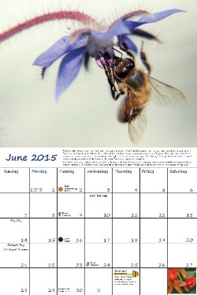

**Beekeeping Calendars ($15)**

**Great for keeping your 2015 colonies’ records**

**Name Tags $8**

**Honey Plants by Tom Britz**



The weather has been atrocious this past month. There have been a few days when the weather has been warm enough for the bees to at least to take a cleansing flight or two. It seems as though most trees have hardly progressed in the process of blooming from three or four weeks ago.

The pollen will soon be rolling in from various sources. Here are a few colors to look for. Maple, depending on the variety can range from light yellow to olive drag green to brown. Apple, white to yellowish. Willows, lemon yellow. American Elm, light grey.

I have included a chart compliments of Midwestern Beekeepers Honey Plants Committee from early 1990 handwritten and sketched by “Chet”. If anyone knows who this individual is let me know so we can acknowledge him sometime.

There is going to be a plant sale at the City Market coming in April. The dates are April 18 and 25. These plants are offered by the Missouri Prairie Foundation.

Here is a link to native pollinator plants:

<http://www.xerces.org/wp-content/uploads/2014/09/MidwestPlantList_web.pdf>

**Basic Principles for Pollinator Landscape Designs**

There are a few basic principles that landscape designs for pollinator gardens share. First, they all attempt to maintain open, unshaded conditions. While some trees are excellent pollen and nectar sources, most bees and butterflies prefer sunny landscapes and meadowlike conditions. Trees are often best along property edges or the north sides of buildings here wildflowers are difficult to grow.

The second feature is a diversity of flowers that bloom throughout the growing season. Designs should have at least three different flower species in bloom. This minimum standard should be maintained for each of the seasons—spring, summer, and fall—as well as winter if you live in a warm climate. This three-species-per-season benchmark should be considered a minimum rather than an end goal.

Finally, each design should demonstrate a landscape rich in color and reduced of grasses. Pollinators are most attracted to large blocks of color and forage most efficiently where the same flower species are clustered together. With that in mind, consider grouping single species together for maximum effect.

This excerpt was taken from The Xerces Society Guide, *Attracting Native Pollinators, Protecting North America’s Bees and Butterflies*, page 264. This book is available for loan from the Midwestern Beekeepers Association library.

Happy Beekeeping,

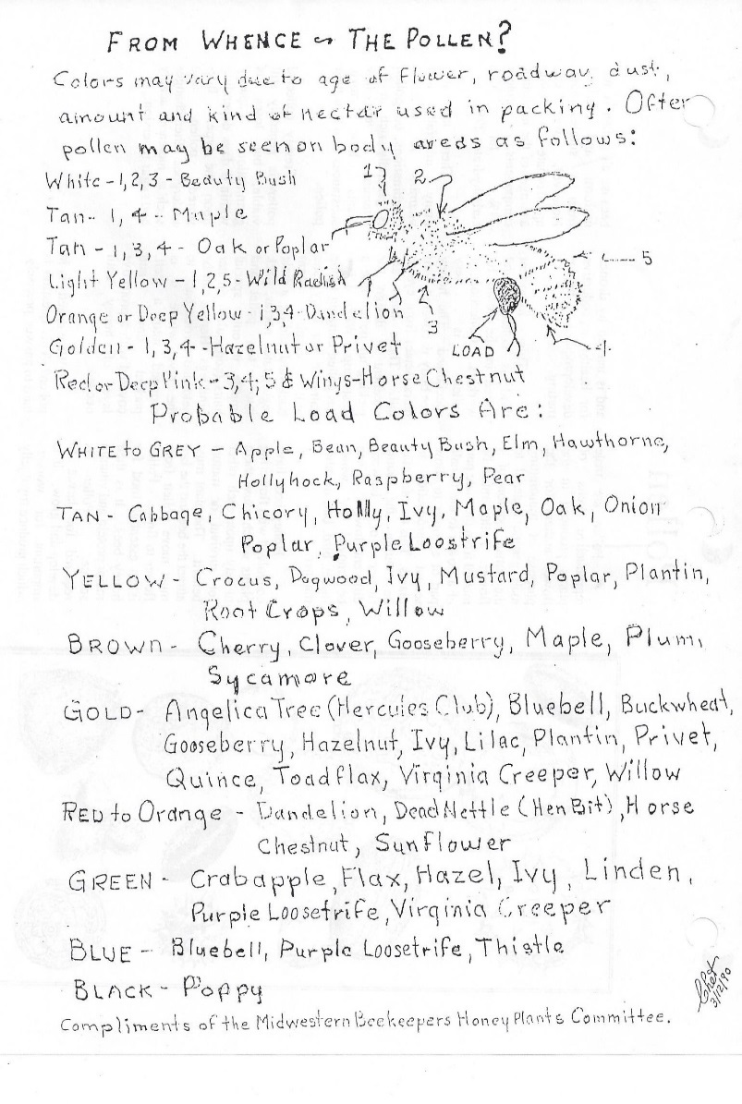Tom Britz 

*Roger Nichols*

**Member Spotlight**

*Being a beekeeper has been a great chapter in my life and with my son, Jerry’s continued help and strong back, we still have several years ahead of us.*

***How did I become interested in keeping honey bees?*** When I was about 9 or 10 years old we went to visit my Uncle Charlie and he was getting honey from one of his bee hives. He saw my brothers and me and told us to stay back. After a while my brothers drifted away to play but I stayed and watched until Uncle Charlie was finished. He came over to where I was and told me to hold out my hand, and then placed a bee in my hand. I was scared but he told me it was a drone and it wouldn’t sting. I gently closed my hand around the bee. It was buzzing and walking around in my hand, it tickled. He told me to go hold my hand up to my mother’s ear. As I think back on it I’m sure it was just to give her a scare, as old brothers sometimes do to their sisters, and it did. I soon learned which bee I could pick up and which one I couldn’t without paying the price. My dad would tell stories about when he was young. His father would find bees getting water and sprinkle flour on them so he could follow them back to their next. He knew when honey bees collected water they would fly directly back to their nest. He would mark the tree and go back later, to cut the tree down, take out chunks and harvest the honey in a washtub, and set the hollow log with the bees in the back of the house.

***When did I start keeping bees?*** Well, it goes something like this; as our family got larger we started going through a lot of honey. My wife Sue was buying a five pound jar about every week. She noticed that the Raytown High Schools were having adult education classes and one of them was a class on beekeeping. I told her that I would do the heavy lifting if she wanted to take the class. To make a long story short she took the class and we ended up with two hives in our backyard. The second or third time she checked the bees to see if they needed supers Sue got stung and had an allergic reaction. So now here I am **a beekeeper**! (After all I did agree to the heavy lifting.) We had purchased the hives from the instructor of the adult education class, Mr. Joe Maher. Since Sue took the class and not me . . . guess who got a lot of phone calls. Joe was an invaluable source of information and advice. He was also involved with the Midwestern and Missouri State Beekeepers Associations and invited me to come to the meetings as well. I got a lot of great information from those meetings, because as all beekeepers know when you ask two beekeepers a question you will get at least three answers.

***Where are your bees located?*** I have numerous bee yards throughout the area from Lawson to Harrisonville, Missouri.

***What processes have you done to learn about managing your bees?*** Most of my learning came through the knowledge of the other beekeepers like George Vanarsdalle of Osage Honey Farm and Joe and my own experiences and observations with my hives or in helping others with their bees. For a couple of seasons I was close to running 700 hives and you learn a lot with that many hives. I started to help Joe with the adult education classes that he continued to teach and after a few years he asked me to take over teaching the classes. In order to prepared for teaching the class I did a lot of research on the history of keeping bees, different techniques used and their effectiveness through books, films and my own continuing education. In March of 2000 I competed the University of Nebraska’s Mid-West Master Beekeeper Program and was presented my certificate by Marion D. Ellis, now Dr. Ellis.

***What have been your greatest hurdles in keeping bees?*** My greatest hurdles have really come in the last few years. Like many beekeepers not only here but around the world it has been very difficult just keeping the bees alive. Changes in the weather patterns have also made it hard to get a honey crop.

***What has been our greatest success in keeping bees?*** I would have to say that my biggest success personally in beekeeping has been the ability to start my own family company and being able to wholesale honey to area grocery stores, restaurants, and a bakery here or there. My wife and sometimes my daughters or grandson are able to sell honey and baked goods at a couple of famers markets through the summer and fall including a shop at the annual KC Renaissance Festival. (Booth 204 come by and see us this fall.) On a wider scale the work I have been able to do with and through the Midwestern Beekeepers Association and helping to increase its membership by encouraging the start of the Beginner Beekeeping Workshops, which is still in practice today some 20 years later with the hard work and dedication of many of our long term members.

***Do You Author a Beekeeping Blog or Website?***

**Members are invited to post their personal beekeeping blog or website on our webpage under “Member Shares.” Just email our webmaster and provide your contact.**

**Do you have a member beekeeper you would like to see featured in Member Spotlight?**

**Contact Janice Britz at** [**britzjs@gmail.com**](mailto:britzjs@gmail.com) **or at 816-419-1327 with your suggestions.**

From The Editor

By Janice Britz

Over the winter months, I have used the Midwestern Beekeepers’ lending library extensively determined to be a better beekeeper come March. Tom and I make a good pair, what I forget, he remembers and vice versa! So here we are and ready to go—yet still we will be doing things by trial and error. To quote Roger Nichols, “because as all beekeepers know when you ask two beekeepers a question you will get at least three answers.” Personally, I find that somewhat frustrating because I just want someone to tell me how to do it and that’s what I do and I am wildly successful! But, as in life, it doesn’t work that way. In my belief, God has made everything beautifully unique yet interdependent. We are forced to be open to ideas, yet discerning to our own situation and forge a path of success on our own two feet. With that said, it makes me appreciate our association and the knowledgeable group of people willing to share their experiences with me.

So what did I gain over all my reading through the winter? I have learned that we have been “reactive” beekeepers and we need to be “proactive” and anticipate the season. This spring we will be more active in looking for congestion in our hives to prevent swarming and we will put our supers on in plenty of time before the honey flow.

Once we pull our supers of honey in the summer, we are going do a better job of mite control and feeding our bees for their winter stores, and so on and so forth. “By seeking and blundering we learn.” ― [Johann Wolfgang von Goethe](https://www.goodreads.com/author/show/285217.Johann_Wolfgang_von_Goethe).

I have a lot to learn about queens and re-queening. One basic I am going to master is marking my queens. I am looking forward to the upcoming queen-rearing class in May by Cory Stevens. This class is full, so I assume many are anticipating the class as well.

If you have any suggestions and comments about the newsletter, please let me know. If you did not receive an email notice from Midwestern Beekeepers in February, please be sure to contact Tanya Fisher to verify your email address we have on file.

No matter if you are a beginner or a seasoned beekeeper; I wish for you a successful and productive start to spring!

Janice

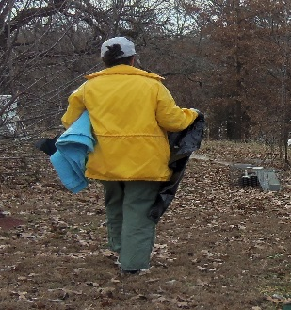Cathy’s True Story

Repeatedly, as I inspected my apiary I would find quart jars scattered along with their bright sock covers torn off and shredded. Scat or spit…who knows but the stuff was full of bees and decorated the front of the hives. The bees were grouchy; flying loudly out of their entrance when disturbed…I knew that I had pests.

Rushing to the barn I removed our trusty raccoon cage and loaded it with giant marshmallows sure to catch a coon. Upon the following morning’s inspection I was rewarded with the offending pest. However all I could say was, OH STINK! I had caught a skunk and did not know what to do. My husband agreed to shoot it but what if the bullet ricocheted off the cage hurting my husband?

I decided to be environmentally considerate and relocate the thing!

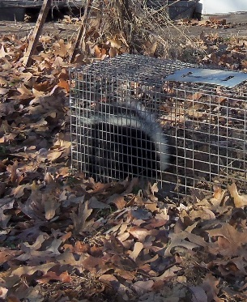 It wasn’t as easy asI thought. These critters are nocturnal and sleep during the day. Wearing clothes that I did not mind burning, I snuck up on the pest. My heart was pounding out of my chest and my knees jiggled like jello. The crunch of oak leaves woke his majesty and those black beady eyes stared at me. I held my breath and fearfully placed a blanket on one edge of the cage. As I slowly stretched, the thing wriggled and …I could not do it! I went to the house to get the mechanical extend-an-arm and was able to finish the job, covering the cage completely.

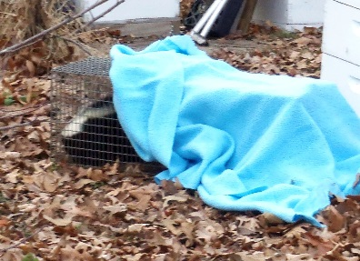Now to wait until his majesty fell back to sleep. After a few hours, enough to get my nerve, I clothes-pinned a plastic curtain on the cage just in case a spray would shoot out! I gently ratcheted the cage in my truck and drove to my favorite farmer friend’s field.

I opened the c age, ran and nothing!

I threw rocks at the cage, ran and nothing!

I honked the horn and nothing… Did I accidently kill it? I then prayed, picked up the cage and shook the thing out and then ran as fast as I could to hide behind my truck…He lifted his tail and ran to the woods. I was safe but now there are signs that the rest of his friends were left behind…? Better nail rug tacks on the hives’ landing boards and stock up on marshmallows!

**Midwestern Beekeeper’s Association**

**2015 MIDWESTERN BEEKEEPERS MEMBERSHIP APPLICATION**

PLEASE CHECK ONE: ____RENEWAL ___ NEW MEMBERSHIP

NAME: __________________________________________________

SPOUSES NAME: __________________________________________________

ADDRESS: __________________________________________________

CITY: ________________________________STATE:_____________

EMAIL ADDRESS: __________________________________________________

WOULD YOU LIKE TO RECEIVE THE BEELINE BY: ___EMAIL ___MAIL

INDIVIDUAL MEMBERSHIP: $15 _____

FAMILY MEMBERSHIP (2 CLUB VOTING RIGHTS): $18 _____

YOUTH SCHOLARSHIP DONATION: _______

TOTAL: ________

How did you hear about the club? _____________________

Make checks payable to:

Midwestern Beekeepers Association

Mail to:

Tanya Fisher, P O BOX 132, Raymore, MO 64083

Questions: [jtfish85@aol.com](mailto:jtfish85@aol.com) or 816-322-9245

Missouri State Beekeepers Membership Fees can be paid by Pay Pal at [mostatebeekeepers.org/joinmsba/](http://mostatebeekeepers.org/joinmsba/)

Or mailed directly to: MSBA*, c/o Steve Moeller, PO Box 7514, Columbia, MO  65205*

**MARKETPLACE**

**Crooked Hill Beekeeping, LLC.**

**Bill and Tammy George**

19133 LIV 355, Chillicothe, MO 64601,

(660)214-0132

www.chbeekeeping.com

Open by appointment most days. Store is located on our farm; early, late and weekend hours are available.

Packaged bees and NUCs available in the spring. Locally manufactured high quality woodenware in stock.

We offer a complete line of beekeeping supplies and equipment. Including: Woodenware (assembly and painting available), frames, foundation, smokers, tools, bee suits, Bug Bafflers, veils, books, feed supplements, honey containers, extracting equipment, NUC boxes, materials to build your own hives (lumber, hardware cloth,etc.)

**Draper’s Super Bee**

**Brenda and Larry Draper**

914 S Street, Auburn NE 68305

402-274-3725

Monday through Thursday 8 am to 5pm. Closed from 12 to 1 pm.

We offer fast and courteous service to all beekeepers. We sell all the supplies for beekeeping supplies, containers, bee pollen and honey for those who run short. Order is shipped the same day as received in most cases. Free catalog available on request. Pick up orders at our warehouse must be pre-ordered and picked up by appointment only**Fisher’s Bee Supplies**

**Ed Fisher**

4005 N.E. 132nd Street, Smithville MO 64089

816-532-4698

Monday through Friday from 9 am to 5 pm Saturdays after 8:30 am Call in advance to make sure we are here. We carry a complete line of beekeeping supplies. See us for your woodenware, smokers, containers, foundation, extractors, beekeeping books, queens and package bees. We also have extractors for rent. We will trade your wax for supplies.

**Do you need your honey supers extracted? If so, contact Jim Fisher 816-918-6648 for custom extracting**

**Heartland Honey and Beekeeping Supplies**

**Joli Winer and Cecil Sweeney**

19201 S. Clare Rd., Spring Hill KS 66083

(913) 856-8356

[joli@heartlandhoney.com](mailto:joli@heartlandhoney.com)

Monday through Friday (closed Wednesday) from 10:30 am to 5:30 pm and by appointment

We appreciate when you call your orders in ahead.

We carry a complete line of beekeeping supplies including woodenware, smokers, extractors, books, queens, package bees and containers. We will trade wax for supplies.

**Jordy’s Honey**

**Robert Hughes**

12333 Wedd Street, Overland Park KS 66213

913-681-5777

Monday through Friday 8 am to 6pm Weekends by appointment

Please call in advance so we can have your supplies ready when you arrive. We carry a full line of beekeeping supplies. Bee hives, supers, frames, foundation, honey containers, smokers, beekeeping books, queens, packaged bees and much more.

**TANYA FISHER**

**P O BOX 132**

**RAYMORE MO 64083**

**ADDRESS SERVICE REQUESTED**

***ATTENTION***

**General Meeting**

**Sunday, March 15, 2:30 pm**

**Graceway Church Fellowship Hall**

**Special Gathering - Nucs**

**Thursday April 2, 7 pm**

**Bass Pro**

**Graceway Church**

**Parking Directions**

General parking is on the West Side and use the main entrance.

Drop-off and wheelchair only access on the south.

**Let’s Pay it Forward!**

Our meetings are free but to show appreciate for Graceway’s sponsorship, please bring on the following to our monthly meeting to aid Raytown Emergency Assistance Program, REAP.

###### *Non – Perishable Food Item*

###### *School Supplies*

###### *New Toy*

 The question that I NEED answered:

Topic that I would LOVE to have covered:

Cut this out and bring it to next month’s meeting or feel free to e-mail me, Laura Fish @ [DDetailsfish@gmail.com](mailto:DDetailsfish@gmail.com) with your questions or topics that you want covered! I look forward to hearing from you!